THE SCHOOL DISTRICT OF PHILADELPHIA
George W. Sharswood Elementary School

STUDENT AND PARENT HANDBOOK
2019 – 2020 School Year

Dr. William Hite Jr., Superintendent
Leigh A. McLinden, Principal

Message from the Principal

As we embark on a year of learning, socializing, maturing and growing, I wanted to take a second to welcome you to the new year. Sharswood has undergone some changes and upgrades. We are through another phase of our revitalization in making Sharswood school a safer and up to date learning environment. It is exciting to see the beautiful and functional changes inside our school.

I want to also thank each and every parent for sending your children, your pride and joy, to us each and every day. Our goal is to partner with you and continue to serve your children in the greatest capacity we can offer. We know that instruction and learning are incredibly important, we also believe that positive experiences and memories play a critical part in ensuring the instruction we offer is received. We want your child’s everyday to be full of memorable moments that will craft them into educationally sound and positive members of their community.

With your continued support, patience, persistence and understanding of the educational process, your children, our children will have some of the best years of their life here at Sharswood. I look forward to working with you and am overjoyed and excited for this upcoming school year!

Leigh McLinden, Principal

Introduction

This document is to serve as communication between home and family. Our goal at Sharswood is to continue to be great partners with you. If you have any questions regarding this handbook please reach out to me. Use it as a reference when you are unclear or need clarification around policies and procedures in our school. I also encourage you to make appointments with your child’s teachers if and when you need assistance regarding classroom instruction and behavior (they will know your student best).

www.philasd.org is also a place where you can find many resources or answers to your questions regarding the School District of Philadelphia policies and procedures at length.

I. ATTENDANCE PROCEDURES

Attendance/Punctuality
Sharswood encourages good attendance. Coming to school each day is critical to academic success. Students who arrive after 8:30 AM are considered late. All students must use the rear Wolf Street door to enter school building. All late students will enter these doors until 9:00AM.

Unexcused Absences
When a student has 3 unexcused absences, a letter will automatically be generated and mailed home informing the parent/guardian of the School District’s concern. After the 6t^{h} unexcused absence, an invitation will be sent to the parent/guardian to attend a meeting to develop an intervention plan to improve the student’s attendance.

Absence Notes
The following procedures will be applied consistently by the administration and staff when dealing with student absence:

1. Students who are absent from school must bring a verifiable excuse note signed by a parent or guardian on the day of their return to school stating the reason for and the date(s) of the absence. The note is to be given to the homeroom teacher. Students must bring the absence note to the homeroom teacher within three days of absence according to Pennsylvania State Law. Until such a note is received, a student's absence will be unexcused. Failure to produce a proper note will result in a coding of unexcused absence in the roll book and on the school computer network. A coding of unexcused absence does not allow for a student to make up any missed schoolwork.

2. Upon returning to school, students are responsible for making arrangements with their teachers to make up the work that they missed as a result of their absence. Teachers also share in this responsibility for determining a reasonable and specific time period for the completion of the missed work. Illness or family emergencies often necessitate a child to be absent from school. If the absence is of significant duration, please contact the school counselor or nurse so that arrangements for assignments and homework can be made. All assignments missed due to absence are to be made up by the student.

For more information regarding attendance/truancy, please refer to the 2019-2020 SDP Code of Conduct found on the philasd.org website.

Reporting to School
Grades K-3 students will line up in center yard for daily admissions closer to 8:25AM. During inclement weather, students will enter the rear Wolf Street door to the cafeteria. To ensure safe arrival of all students, NO parents/guardians will be permitted to enter the building with their child(ren). Students in grades 4-8 will enter rear doors that correlate to the side of the building at approximately 8:25AM. Doors will close and late students will report to Wolf Street side rear door until 9:00AM and will report to the Welcome desk on the 1st floor for late slip. After 9:00AM front doors will begin to open to visitors and late students.

Breakfast
Students can eat breakfast in the cafeteria from 8:05a.m. to 8:25a.m. Students entering the building for breakfast are restricted to the cafeteria area and should enter through the rear door on Wolf Street side. They cannot go to other floors in the building. Kindergarten students will receive breakfast after entering the building at 8:25am.

Lateness to School
All students who arrive late to school must report to the Welcome Desk up until 9AM and will enter the building from Wolf Street rear door. After 9AM students may enter the front doors on 2nd Street and will receive a late slip from the main office. ** New state law – students who report late after 10:26 am or leave early before 1:00 will be marked as half a day absent. Every two half days will add together to make a whole day.

Religious Observation
Students who are absent from, arrive late or leave early from school because of participation in a religious obligation must present a note from their parent or guardian stating the place and time of the obligation.

Early Dismissals
Early Dismissal Policy: According to State Law, all appointments, including medical and dental appointments, are to be scheduled after school hours. Early dismissal will be granted only when the parent/guardian comes to school for the student. Early dismissals are granted for certain types of medical and personal emergencies. Medical and dental appointments should be scheduled after school hours. For medical emergencies, see the school nurse. All students being dismissed early due to illness must have a parent or guardian pick them up and sign them out of the main office.

In order to conduct a safe dismissal, NO STUDENTS WILL BE DISMISSED EARLY AFTER 2:30. PARENTS MUST WAIT UNTIL THE 3:00 DISMISSAL.

ACT 29 of 1995 (TRUANCY)
Students cutting school are truant. Students who do not bring in an excuse note are considered truant. Truancy petitions will be prepared and turned over to the proper authorities for legal action(s), including fines, etc. to students and parents/guardians. Act 29 provides for a $300 fine and allows the court to impose parent education classes and community service sentences for parents of a truant child, who do not show that they took reasonable steps to ensure their child’s school attendance. It provides that the parent and child must appear at a hearing before the district magistrate.

II. ACADEMIC INFORMATION

Grading System
The following relationships between numerical averages and literal marks have been established system wide.
A = Excellent = 90 -100
B = Good = 80 - 89
C = Satisfactory = 70 - 79
D = Passing (Meets minimum promotion requirements) = 65 - 69
F = Failure (Subject in danger of being repeated) = *64 and below
I = Incomplete (Insufficient grades for the marking period)

Report Card Conferences
Report card conferences are held three times a year. Parent attendance at conferences is critical to the success of our students. A form will be sent home 3-weeks in advance of the conference dates for parents to state when they are able to meet with their child’s teacher to discuss their progress. Students will be dismissed at 12pm. on the report card conference dates.
Scheduled Conference Dates –
November 20 - 22, 2019
February 5 - 7, 2020
April 15 - 17, 2020
The final report card will be sent home with the student on the last day of school.

Parent Conferences
Parents/guardians are encouraged to contact the school to make an appointment with the teacher, counselor or administrator whom they wish to see. However, to minimize classroom disruptions, conferences are not permitted when a teacher is scheduled to teach a class.

Honor Roll
Honor Roll at Sharswood School consists of two categories: Principal’s List and Honor Roll. To be eligible for Principal’s List, a student must have all grades of A on his/her report card and no poor behavior comments. To be eligible for Honor Roll a student must have a combination of grades of A or B or all B on his/her report card and no poor behavior comments. Recognition of Principal’s List and Honor Roll occurs at the end of the school year.

Student Records
The school has the need to collect and maintain certain information related to the health, education and welfare of its students. This information is vital to the continuity of the school’s educational program. Federal and state laws provide safeguards to the privacy of such records and guarantee access to these records by parents or guardians and students. Parents/Guardians have the right to inspect and review the educational records of the student. A written request for such inspection is to be submitted to the counselor or in the main office. A parent or guardian who wishes to review the records of a student for whom he/she is responsible should contact the student’s counselor for an appointment or present a written request to the counselor for such an inspection. Such requests will be granted as soon as possible, but not later than 14 days from the date of the request. Students under eighteen (18) years of age must have written permission from their parent or guardian prior to viewing their educational records.

III. UNIFORM POLICY

1. Students must be in full uniform every day. The uniform is: Khaki bottoms (pants, skirts, shorts, or jumpers, all to knee length) and navy blue shirts, long or short sleeves. Shirts cannot have logos on them other than Sharswood. Knee length shorts are acceptable. Hoodys are prohibited however, students may layer under uniform shirt and/or wear navy blue sweater or navy blue crew neck sweatshirt. Gym shirts are available for purchase.

2. Grooming and Personal Safety
· Students are expected to show good judgment and show respect for themselves and others in their dress and grooming.
· No open toe shoes permitted.
· Non-prescription sunglasses, hats, clothing that exposes armpits, a bare back or midriff, see-through clothing, and accessories with protruding metal spikes are not to be worn in school.

3. Hats, Footwear and Outerwear
· Non-religious headwear are not to be worn in school at any time (small head bands are permitted). All hats are to remain in the student’s school bag at all times.
· Boots, flat-heeled dress shoes, enclosed toe sandals, and sneakers are permitted.

IV. SCHOOL-WIDE POSITIVE BEHAVIOR SUPPORT SYSTEM

Sharswood School prescribes to a tiered structure of recognizing the positive in each and every one of our students while also holding students accountable for their actions. This tiered system is known as Positive Behavior Intervention and Support (PBIS).

We are continuously working on creating a positive school culture. We have created a PBIS “Sharswood Style” system to support school climate and culture. Students will have weekly, monthly and quarterly attendance and behavior incentives. Please stay updated and read weekly updates to see our latest happenings. All parents are encouraged to contribute and participate in our events. Please see the front office on how to be a volunteer at Sharswood’s PBIS events.

ClassDojo
All parents and guardians can track student classroom behavior through ClassDojo - an online website that you can login to via your computer or smartphone app. Communication around this progress with teachers and administrators is highly encouraged.

You will receive a password and username from your student’s teacher. Through this application you will be able to see school-wide events, work that your student is doing in class and much, much more! We encourage 100% of parents to follow their student’s progress on ClassDojo.

V. SCHOOL DISTRICT OF PHILADELPHIA DISCIPLINE PROCEDURES

Sharswood as a School District of Philadelphia School adheres to the Student Code of Conduct as published by the School District of Philadelphia and requires students to follow all of the policies and procedures therein.

Below you will find a summary of the School District of Philadelphia Student Code of Conduct. The latest version of the handbook can be found at http://www.philasd.org and translated copies can be obtained by calling 215-440-4180.

The Code of Student Conduct establishes policies, rules, and expectations for all school community members to learn, teach, and work together.

Consequences for students who endanger school safety or disrupt the educational experience of others are listed in detail. The Code of Student Conduct applies during school and on the way to and from school, including, but not limited to travel on School District vehicles, private transportation, and public transit systems.

Families and guardians are critical to our community. We ask that they please read and understand the Code of Student Conduct and School Student Handbook, and discuss them with their children. We understand that families and guardians know best how to make sure that their children understand the expectations that will lead to a safe and orderly school community.

This Code of Student Conduct provides definitions of disruptive behaviors. Although some definitions include examples, the behaviors include, but are not limited to, the examples given.

Parents, guardians, and caregivers who have any questions or concerns are encouraged to contact the school principal and/or the Office of Student Rights and Responsibilities at phone number 215-400-4830 or website - https://www.philasd.org/studentrights/

Please see the following pages for behavior matrices.

BEHAVIOR MATRIX (taken from 2019-2020 SDP Student Handbook)
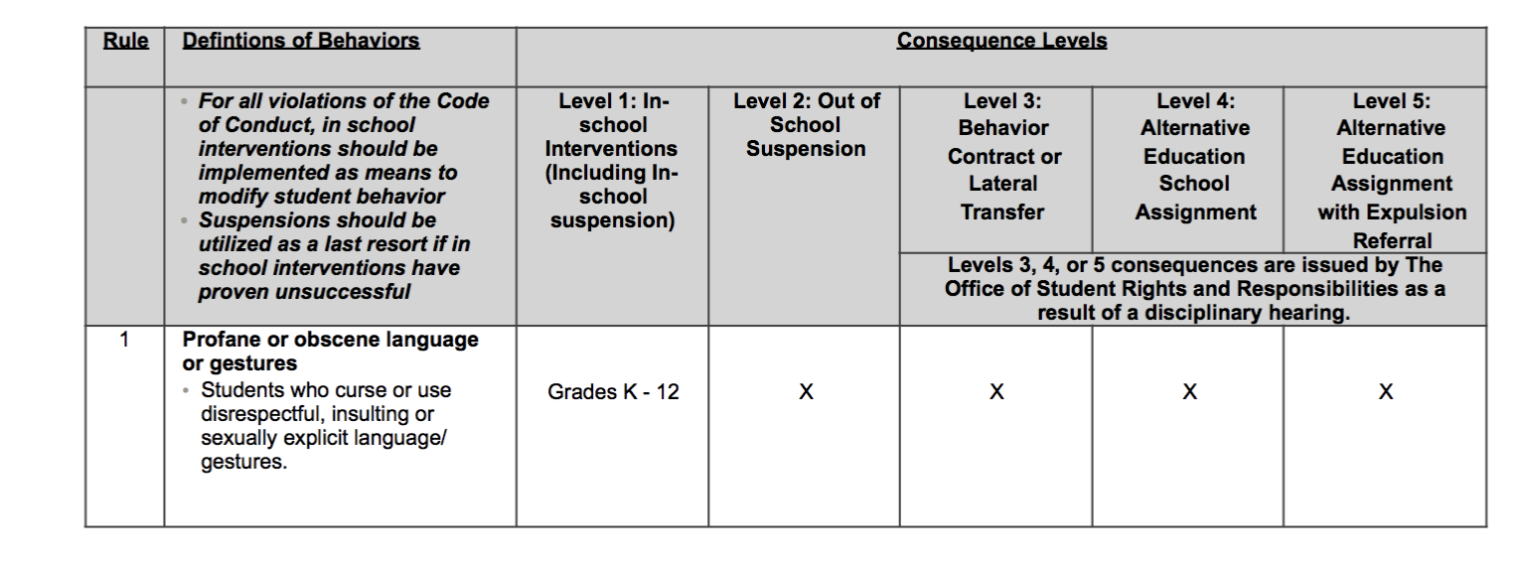
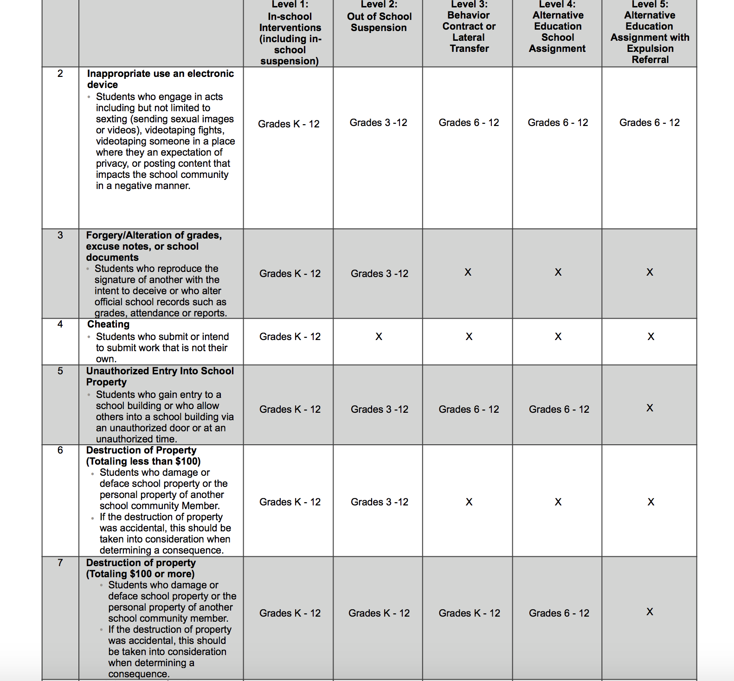
Student Expectations and Conduct
The staff of the Sharswood Elementary seeks to provide a school atmosphere that is free of disruption and allows students to develop a sense of responsibility, self-respect and respect toward others. Our goal is to have our students develop into productive citizens in our community. We expect our students to develop these qualities by following the rules listed in the School District’s Student Code of Conduct. Discipline and good citizenship are shared responsibilities of the school administration, the teachers, the students and our parents. When we all work together the children benefit. Appropriate school staff will contact parents when the need for intervention/support is evident. Parents should share their concerns with school staff and should encourage students to do the same.

Sharswood School
Progressive Discipline Procedures
Violation | First Offense | Second Offense | Third Offense | Fourth Offense
Bullying  Bullying occurs when someone repeatedly and purposely say or does mean or hurtful things to another person who has a hard time defending him or herself.  Harassment  is defined as un-welcomed verbal, written, graphic and /or physical conduct that is related to one’s gender, age, race, color, sexual orientation, gender identity expression, national origin, religion, disability, English language proficiency, socioeconomic status or political beliefs  https://www.philasd.org/bullying/information-for-parents/defining-bullying/ | Grades K - 12  - Parental Notification  - Student’s name is added to a bullying watch list.  - Student will be required to participate in peer mediation session.  - Strategic Intervention to Modify Behavior  - Dean involved | Grades 3 - 8  - Parent Conference  - Student suspension  - Entered into MTSS  Grades K - 2  - Student will be assigned to a Reflection Room.  - Student will meet with teacher mentor or counselor.  - A safety plan will be created for all parties.  - Entered into MTSS | Grades 3 - 8  - Behavior contract  - Lateral transfer  Grade K - 2  - Bullying Incident filed with the Office of General Council.  - Student’s schedule is altered.  - Student will be required to enter the “check-in/ check-out” process for one week. | Grades 3-8  - Alternative Education School Assignment  - Student suspended.  - Student will be recommended for SAP  Grades K - 2  - SAP assessmentSt
Fighting/Reckless Endangerment  Students who take any action that creates a substantial risk such that serious bodily harm could result to any person. For example, throwing objects across the room out of a window | - Student will be required to participate in a peer mediation session.  - Student will not be allowed to participate in school activities (recess and afterschool clubs) for one week.  - Strategic Intervention to Modify Behavior  - Possible Suspension  - Dean involved | - Student will be required to participate in a peer mediation session.  - Student will be required to enter the “check-in/ check-out” process for one week.  - Student will be required to perform 2 hours of community service at Sharswood. (3-8)  - In-School Suspension (3-8)  - Buddy Room (K-2) | - Student will be required to participate in a peer mediation session.  - Student will be required to enter the “check-in/ check-out” process for two weeks.  - Student will be required to perform 2 hours of community service at Sharswood  - Out of School Suspension (3-8) | - Student will be assigned out of school suspension. (3-8)  - Student will be recommended for SAP  - Student will be recommended for a disciplinary transfer (6th-8th grade).
Walking Out of Class/Eloping | - Student will be escorted back to class.  - Teacher Classroom Management Techniques (i.e. Make-up missed minutes with teacher).  - Parent Notification by teacher | - Student will be brought back to class.  - Teacher Classroom Management Techniques.  - Daily Report for 1 week.  - Parent Notification by teacher | - Student will be brought back to class.  - Teacher Classroom Management Techniques/ Strategic Intervention to Modify Behavior.  - Parent Conference  - Daily Report for 2 weeks.  - After school community service at Sharswood.  - Dean involved | - Student will be brought back to class.  - Teacher Classroom Management Techniques.  - Parent Conference  - Daily Report for 1 month.
Electronic Devices  (All students have the option to turn the device in at the start of the day.) | - Student yields the device.  - Student retrieves the device from the office/dean at the end of the day.  - Incident noted  - Dean involved | - Student yields the device.  - Parental Notification  - A parent/guardian will be required to pick up the device. The device is not returned until parent comes in. | - Student yields the device.  - Parental Notification  - Parent/guardian will be required to pick up the device. The device is not returned until parent comes in. | - Student yields the device.  - Parental Notification  - Parent/guardian will be required to pick up the device. The device is not returned until parent comes in.
Dress Code Infractions | - Parental Notification  - Student will be given a lender uniform | - Parent Notification  - Student will be given a lender uniform | - Student will be given a lender uniform  - Student will receive a Parent Conference
OFFENSIVE/  PROFANE LANGUAGE/  GESTURES  &  Insubordination | - Classroom Management Strategies: Lunch/After School Detention, Writing Assignment, 1 to 1 Conference, Buddy Teacher, etc.  - Parental Notification | - Classroom Management Strategies: Lunch/After School Detention, Writing Assignment, 1 to 1 Conference, Buddy Teacher, etc.  - Parental Notification  - Daily Report (2 weeks) | - Classroom Management Strategies: Lunch/After School Detention, Writing Assignment, 1 to 1 Conference, Buddy Teacher, etc.  - Parental Notification  - No participation in school activities (2 weeks.)  - Daily Report (1 month) | - Parent Conference  - No participation in school activities- 2 weeks.  - Daily Report (1 month)  - Harassment Incident filed with the Office of General Council.
DESTRUCTION OF SCHOOL PROPERTY/ Theft | - RESTITUTION  - Parental Notification  - 1 hour of Community Service/after school detention .  - Strategic Intervention to Modify Behavior | - RESTITUTION  - Parental Notification  - 2 hours Community Service (3-6)  - 60 minutes community service (K-2) | - RESTITUTION  - Parental Notification  - 1 day suspension (3-6)  - Serious Incident Filed | - RESTITUTION  - 2 day suspension (3-6)  - Serious Incident Filed- Disciplinary Transfer Recommended
Forgery | - Parental Notification  - One Hour Community Service  - Dean involved | - Parental Notification  - 2 Hour Community Service sessions (3-6)  - Possible Serious Incident Report | - Parental Notification/ Meeting  - 2- Day Suspension (3-6)  - Possible Serious Incident Report
Electronic Misuse | - Yield device to the teacher  - Termination of use for the 2 weeks.  - Parent Notification  - Dean involved | - Yield Device to the teacher  - Termination of use for 1 month  - Parent Notification | - Termination of use for 3 months.  - Parent Notification  - Possible Suspension (3-6) | - Termination of use for the remainder of the school year.  - Parent Notification  - Possible Suspension (3-6)
Weapon  Any object, device, or instrument, which, in its inherent and functional purpose is intended to be a weapon, including any firearms, whether loaded or not, cap guns, pellet guns, BB guns, knives, box cutters, cutting instruments, nunchaku, or mace. This does not include ordinary objects such as pencils. | - Immediate Parent Conference  - Referral to Counselor  - Report to School Police  Suspension  - K-3 In- School  - 4-5 Out of School  - 6-8 Out of School/ Disciplinary Transfer Filed  - Administrator/ Dean involved | - Immediate Parent Conference  - Referral to Counselor  - Report to School Police  Suspension  - K-2 In- School  - 3-5 Out of School  - 6-8 Out of School/ Disciplinary Transfer Filed  - Administrator/ Dean involved
Inappropriate Touch | - Parent Conference  - Counselor Referral  - Strategic Instruction to Modify Behavior  - In-School Suspension  - Dean involved | - Parent Conference  - Counselor Referral Strategic Instruction to Modify Behavior  - In House Suspension  - Grade 3-5  - Out-of-Suspension  - Grade 6-8 | - Parent Conference  - Counselor Referral  - Strategic Instruction to Modify Behavior  - Out-of - School Suspension  - 3-6 | - Student will be recommended for a disciplinary transfer (6th grade).

Student Detentions
Detentions may be assigned for minor discipline infractions. Students are required to report to detention on time. Students will participate in a reflection activity, and sleeping is not permitted. Students may not listen to ipods or other electronics during detention. Students must observe the Student Code of Conduct while serving a detention. Students who fail to serve assigned detentions or who accumulate an excessive number of detentions are subject to further disciplinary action.

Suspensions
A suspension for a period of up to five (5) school days may be given by the principal or Dean to a student for committing any act of serious misconduct, as outlined in the School District’s Code of Conduct. The purpose of a suspension is to have both the pupil and parent recognize that the pupil was involved in serious misconduct. A conference is held to discuss the reasons for the suspension and cautioning that the misbehavior must not be repeated. Parents are informed in writing of all suspensions and the date and time for a scheduled reinstatement conference. Continuous violation of the school discipline policy will result in request to transfer student to a remedial discipline school.

Reinstatement from Suspension
Reinstatement after suspension for disciplinary action will occur at the scheduled time only. Reinstatements will only be held with the legal parent/guardians listed in each student’s record. Any persons not listed as a legal parent/guardian may not be involved in any school related activities or information for that student, including reinstatements from suspensions. If you cannot attend the assigned time, call the main office and ask for the principal or climate manager so that we can accommodate your schedule. The parent/guardian whose name appears on the school records must accompany the student for reinstatement. Phone reinstatements are not permitted.

VI. SCHOOL-WIDE POLICIES AND PROCEDURES

Buddy System
Students in Kindergarten to 3rd grade must use the buddy system any time they leave the room to go to the office of the bathrooms. Students must have a signed pass from the teacher explaining where the students are going. The date and time must be on the pass.

Cell Phone Policy
The George Sharswood Elementary staff understands the importance and essential reasons for students to carry cellular devices. Therefore, we have decided to give students the privilege, not a right, to possess cell phones that are turned off and left in their school bag during school hours. Students and parents must read the policy on this form carefully, discuss the content and any of their questions, sign and date this form, then return the form to their homeroom teacher.

Responsibilities come with this privilege:
- Students should not have cell phones out at any time during the school day.
- Students may not use their cell phones to interfere with their learning and the learning of others in their classroom and building, may not be disruptive to the educational process and may not negatively affect the School’s mission or environment.
- Each student is solely responsible for their own cell phone. Sharswood and the staff assume no responsibility for devices if they are lost, stolen, or loaned.
- Sharswood will not be responsible for students’ actions or inactions conducted through cellular devices.
- The first occurrence of having a phone, Sharswood will confiscate the phone and the student will be permitted to pick up the phone at the end of the day. Failure to turn over the phone may result in disciplinary action.
- Occurrences of having a phone confiscated beyond the first, Sharswood will confiscate the phone and the parent will need to pick it up. The student will also have disciplinary consequences. Failure to turn over the phone may result in disciplinary action.
Counselor
The counselor is available to students and parents wishing to discuss any matter related to school or home. Parents may make appointments by telephoning the counselor. Students may make appointments by filling out a counseling request form and submitting to their homeroom teacher or putting in the counselor’s box.

Emergency Closing of Schools
First check the Philadelphia School District website for the most current announcements. www.philasd.org. Announcements will also be made over the radio and local TV beginning at 5:30 am. Mid-day weather closing is also announced via the local media. If, for any emergency, schools must be closed during the school day for other than weather, the administration will announce the closing to the students and send a robo-call to parents.

Emergency Response Plan
Sharswood has developed a "Crisis Response Plan" that is designed to minimize danger to anyone occupying the school should an emergency occur. Our main objective is to attend to the health and welfare of our children in the event of a crisis. In most emergencies, the children will remain in the school. In the rare event of any emergency that prohibits re-entry into the building (such as fire, electrical outage, gas or water main breakage) we will evacuate the students to another location. The location will be posted on the front doors, parents will receive a robo-call, and KYW news will be notified to make an announcement. If it is determined that the emergency requires that no one exits the building due to dangers in the outside community (toxic chemical spill, terrorist attack, disturbance in the area, intruders), we will activate a "Shelter in Place" procedure. During this procedure, all doors will be locked. We will be unable to open the doors for anyone, including parents wishing to take their children home. Doors will remain locked until we are given authorization from the School District or Police to unlock them.

During a relocation, parents and guardians must follow the procedures put in place for reunification. They must have proper identification in order to take children from a relocation site. They must wait in an orderly line for children to be located and brought to parents. Parents and guardians may not enter the building to look for children themselves during an emergency.

Fire/Shelter in Place/Lockdown Drills
Fire drills are conducted once a month. Shelter in Place drills are conducted once a year. Lockdown Drill are conducted twice a year. When a drill is conducted, students are to follow the directions given to them by their teachers.

During a fire drill, they will evacuate the building. Students may not leave the school group during the fire drill.

During the Shelter in Place Drill, students will be directed to the inside shelter location. No one (including parents and/or visitors) will be permitted to enter or leave the building during these drills. A Shelter in Place would occur when there is something being released in the environment that would be unhealthy. It would be a temporary relocation. The Fire Dept. or City Officials would make the decision for this type of relocation. There wouldn’t be the same urgency as a fire drill but it is important that everyone is relocated. It is important that the students remain calm and orderly, not absolute silence but you will need to be able to hear announcements.

Lockdowns occur when there is imminent danger inside the building. During a Lockdown, students will remain in classrooms/offices out of sight of door until the lockdown is lifted. In order to be ready in the event an incident occurs, students must practice this drill twice a year. You will be notified the week before one of these drills occur for clarity and communication purposes.

In the event that we evacuated for a true emergency the places below are where we would connect you with your child.

RALLY POINT/ASSEMBLY AREA(s):
(A safe location to connect with/meet response teams outside of the primary facility)

Primary | Jackson Street Park, 2nd & Jackson Streets
Alternate | Murphy Recreation Center, 300 S. Shunk Street

In the event that we need to evacuate the building (boiler issues, building safety, etc), students would continue instruction in the following locations:
EVACUATION/RELOCATION SITE(s):
(Pre-determined location(s) for staff and students to continue instruction)

Primary | Taggart School, 4th & Porter Streets
Alternate | Furness High School, 1900 S. 3rd Street

Lost and Found
The lost and found box for books and clothing is maintained outside the main hallway. Please do not bring valuable items or large sums of money to school. Students must put their names on all articles of clothing.

Lunch/Breakfast Program (Free and Reduced)
A free breakfast is provided for all students. Sharswood School offers free lunch to every student through the universal feeding program. Pupils may bring their own lunch. Pupils bringing beverages may not bring glass bottles to school and may not bring soda to drink. Students may only eat/drink in the lunchroom. Students must stay in the cafeteria during the lunch period.
Lunchroom
Eating takes place in the lunchroom only (Unless approved by Principal). In order to make the lunchroom and other areas orderly, clean and attractive, all students are expected to wait their turn in the food line in an orderly fashion, keep the table areas and floor areas clean, sit only on the chairs, not the tables, place all trash in the proper receptacles which have been placed throughout the lunchroom, leave the area clean for others to use, use good table and eating manners, and follow directions from staff members manning the lunchroom.

Monthly Calendar/Newsletter
Every month a calendar will be sent home with your child showing important school dates, activities and information for the upcoming month. Please take time to review the information with your child.

Nursing Service
The nurse's main function is to carry out an extensive medical health program mandated by the School District, including vision and hearing tests, physical examinations and monitoring immunization programs, as well as maintenance of medical records. The nurse is responsible for giving first aid or emergency treatment. The nurse is not permitted to give medication for short-term illnesses. The nurse may provide emergency first aid only if a student becomes ill in school. It is the parent's responsibility to get the student from school and follow through with appropriate care at home. Do not send your student to school if he/she is ill. The nurse will not be able to meet his/her medical needs.

Personal Messages
Families are asked not to call the school to deliver personal messages to students during the school day. Office staff is not permitted to interrupt the educational program to deliver messages. If an emergency occurs, please call the child's counselor who will assess the extent of the emergency.

Smoking Policy
By state law and school board policies, all schools are smoke-free facilities. Smoking is not permitted anywhere in the building or on school grounds.

Visitors/Trespass Ordinance
Parents are always welcomed at Sharswood School, but should make an appointment to meet with an administrator, counselor or teacher. For safety reasons, all visitors must report to the main office or Welcome Desk to sign in and to obtain a visitor's pass. They must sign out prior to leaving the building. No visits are allowed to classrooms unless previously scheduled with an administrator. Visits require a minimum of 48-hour notice.

The anti-trespass ordinance provides that within fifteen minutes of entering a school building, permission must be obtained to remain on the premises. Failure to comply with this regulation constitutes a violation and may lead to a maximum fine of $300 and a maximum sentence of 90 days in jail.

Any person entering any school in the District to which he/she is not assigned, without proper authorization, and disrupts the normal business process of the school is subject to arrest for disorderly conduct. Parents are expected to be a role model for their son/daughter and other students in conducting their behavior in a professional and appropriate manner.

Weapons – Act 26
Students found to be in possession of weapons, as defined by State law or School District Policy, will be subject to immediate suspension, arrest, transfer to a disciplinary school and/or possible expulsion (see Act 26 in the discipline section of the School District Code of Conduct) and Act 26 of 1995 (The Safe Schools Act). Act 26 requires that any student, regardless of age, found to be possessing a weapon on school property, in a school program or event, or while traveling to or from a school or school program or event (including school buses and public transportation) be arrested and expelled from the School District for at least one year. If the child is under 17, the parent will be responsible for providing an appropriate education during the expulsion, either at a private school or with another public school district. Violations of Act 26 will become part of a student's permanent record, and will now be available to any school in which he or she may later enroll. It also requires parents to provide a sworn statement upon registering their child in school as to whether the child had previously been suspended or expelled from another school. Act 26 also requires schools to maintain records on acts of violence and weapon possession and to forward student discipline records when a student transfers to another school.

Act 33 of 1995(Delinquent Vs. Criminal Acts)
Act 33 provides that any person age 15 or older who commits a violent crime and either (a) committed the crime with a deadly weapon or (b) has previously been adjudicated delinquent for a violent crime, will automatically be tried as an adult in the criminal justice system.

Special Programs

1. MTSS (Multi-Tiered Student Support)
Students who are at risk because of academic, behavioral, social, emotional, or family-related problems are referred to a comprehensive support team that develops intervention strategies.
2. Special Education Services
Sharswood School offers a range of services to students with special needs. Every effort is made to provide service delivery in the least restrictive environment. Each year, student rosters are individually designed for special education and regular education program options that best suit learning needs and career goals. Related services such as speech, vision, hearing, physical, or occupational therapy are available where these statements of need are included in Individualized Educational Plans (IEP).

VII. SCHOOL CONTACT INFORMATION
At Sharswood, we strive to make our teachers and staff accessible to all of our stakeholders. Below you will find a list of teachers, their room numbers and their email addresses. You can also communicate with teachers through the Class Dojo website/application.
Mailing Address:
George W. Sharswood School
2300 S. 2nd Street
Philadelphia, PA 19148

Main Office Phone: 215-400-8270 Main Office Fax: 215-400-8271

Administrative Meeting Requests: The principal is available after 3:30 daily without an appointment. Appointments may be made to see the principal during the school day by calling the office.

Staff Contact Information:
Head Start
Room 109 - Ms. Kisleiko - jkisleiko@philasd.org
Room 114 - Ms. Siegel - jsiegel@philasd.org

Kindergarten
Room 106 - Ms. Lohan - mlohan@philasd.org
Room 105 - Ms. Hurst - mhurst@philasd.org

1st Grade
Room 107 - Ms. Barille - ajirrera@philasd.org
Room 103 - Ms. Coyle - lmills@philasd.org

2nd Grade
Room 228 - Ms. Urick - mnicodemo@philasd.org
Room 225 - Ms. Clarke - nclarke@philasd.org

3rd Grade
Room 217 - Ms. DeLuca - ndeluca@philasd.org
Room 219 - Ms. Giancaterino - mgiancaterino@philasd.org
Room 223 - Ms. Johnson - cjohnsonlee@philasd.org

4th Grade
Room 330 - Ms. Dembeck - jcdembeck@philasd.org
Room 329 - Ms. Maletteri - jmaletteri@philasd.org

5th Grade
Room 331 - Ms. Caucci - ncaucci@philasd.org
Room 332 - Ms. Prete - ksantilli@philasd.org

6th Grade Cycle
Room 337 - Ms. Wagner (MY SCI) - hwagner@philasd.org
Room 338 - Ms. Coe (MY Math) - acoe@philasd.org

7th Grade Cycle
Room 335 - Ms. Britton (MY SS) - czmack@philasd.org
Room 336 - Ms. Capurro (MY Math) - ccapurro@philasd.org

8th Grade Cycle
Room 333 - Ms. Steinitz (MY ELA) - asteintz@philasd.org
Room 334 - Ms. Arbitman (MY ELA) - larbitman@philasd.org

Learning Support
Room 224 - Ms. Lake - srlake@philasd.org
Room 342A - Ms. Brewer - pbrewer@philasd.org
Room 224 - Ms Fisher - jmcallister@philasd.org
Room 340 - Mr. Stefanelli - astefanelli@philasd.org

Emotional Support
Room 339 - Ms Sweeney - ksweeney@philasd.org

Life Skills Support
K to 3rd - Room 108 - Ms. Schuck - mschuck@philasd.org
4th to 6th - Room 226 - Ms. Pierandozzi - cpierandozzi@philasd.org
7th to 8th - Room 227 - Ms. Polin - djhoffman@philasd.org

Autistic Support
Room 102 - Ms. Porreca - jporreca@philasd.org

School Counselor
Room 341A - Brittany Siegman - bsiegman@philasd.org

School Nurse
Room 104 (Phone #1040) - Ms. Boyce - mboyce@philasd.org

ESOL
Room 342 (Phone #3420) - Ms. Eliasoph - leliasoph@philasd.org

ESOL/SM GR
Room B9 (Phone #4211) - Ms. Lehn - athoang@philasd.org

BCA Arabic
Room 342 (Phone #3420) - Ms. Mahmoud - rmahmoud@philasd.org

BCA Spanish
Room 342 - Ms. Coulter - gcoulter@philasd.org

BCA Mandarin
Room 342 - Ms. Wang - mwang@philasd.org

SBTL
Room 223A - Ms. Flavin-Lefferts - dflavin@philasd.org

Early Literacy Specialist
Room 216A - Ms. LeComte - clecomte@cli.org

Gym
Room 111 - Mr. Burba - cmburba@philasd.org

Art
Room B1 (Phone #4010) Ms. James - gaboyce@philasd.org

Music
Room 216 - Ms. Bui - tnbui@philasd.org

Tech
Room 341- Ms. Metzger - lmetzger@philasd.org

SEL/Dean
Ms. Kosterlitz #1240– skosterlitz@philasd.org

Speech-Language Pathologist
Room B9 (Phone #4211) - Shannon Richardson - srrichardson@philasd.org

VIII. ACKNOWLEDGEMENT OF RECEIPT OF HANDBOOK

After you have reviewed this handbook and the Student Code of Conduct in full, we ask that you sign below as acknowledgement that you have read the documents and that you and your student agree to adhere to these policies and procedures.

I, the undersigned do hereby acknowledge that I have thoroughly reviewed the contents of the Sharswood student handbook as well as the Student Code of Conduct as outlined by the School District of Philadelphia. By signing below, I agree to adhere to all the policies and procedures therein.

Guardian Name (First and Last) Date

Student Name Date

